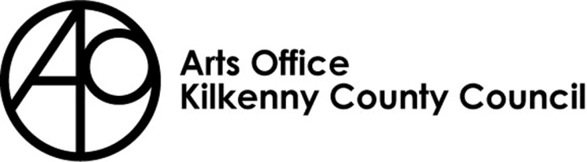

KILKENNY POETRY BROADSHEET 2022
ISSUE 22 - APPLICATION FORM

Kilkenny County Council Arts Office is inviting submissions from poets born or based in Kilkenny City and County for the 22nd Issue of Kilkenny Poetry Broadsheet.

We are delighted to announce that Elaine Feeney will be editor of this year’s Broadsheet.
Elaine lectures at The National University of Ireland, Galway, where she is also a founding member of the Tuam Oral History Project. She has published three poetry collections including The Radio was Gospel & Rise. Feeney wrote the award-winning drama WRoNGHEADED commissioned by the Liz Roche Company. Her novel As You Were won the 2021 Dalkey Book Festival’s Emerging Writer Prize, The Kate O’ Brien Prize and The Society of Authors’ McKitterick Prize. It was nominated for Irish Novel of the Year, shortlisted for the Rathbones-Folio Prize and featured in many Best of 2020 lists, including The Telegraph, Sunday Times, Evening Standard, Telegraph, Guardian & Observer. Feeney was chosen by the Observer as a top debut novelist for 2020.

Rules of Submission

Submissions can be in English or Irish

Submissions must be the work of the entrant (no third party submissions)

Entrants must be 18 years of age or over

Limit of TWO entries per person.

Submissions MUST be typed and no longer than 30 lines

Work MUST NOT be signed

Entrants must be born or based in Kilkenny City or County

Submissions may have been published previously

Details of any such publication must be included with your application

The editor’s selection of published and shortlisted poems is final
- To be accepted for publication the editor may suggest edits to your poem/s for your consideration
- There is no submission fee but entries will not be returned

Please send submissions preferably in digital format (Microsoft Word) by email to deirdre.southey@kilkennycoco.ie . Hardcopy applications can still be submitted to: Kilkenny Arts Office, Johns Green House, Johns Green, Kilkenny.

The closing date for submissions: 4pm Friday 1st April

Further information 056 7794547

KILKENNY POETRY BROADSHEET ISSUE 22

APPLICATION FORM

Name in full (Block letters)

Postal address

________________________________________
________________________________________
________________________________________

Tel. Number

Email Address

Title of Work(s)

- ___________________________________
- __________________________________________

Have you had work(s) (those submitted here or otherwise)
published previously?
Yes No

_______________________________________________
_______________________________________________
_______________________________________________
_______________________________________________
_______________________________________________
_______________________________________________

If so, please give brief details

I consent to the holding and processing of my personal data for the purposes of this application only and I understand that it will not be used for any other purposes.
I confirm that I am 18 years of age or over and I was born or resident in Kilkenny.

Signed: ____________________________ Date:________________________________

